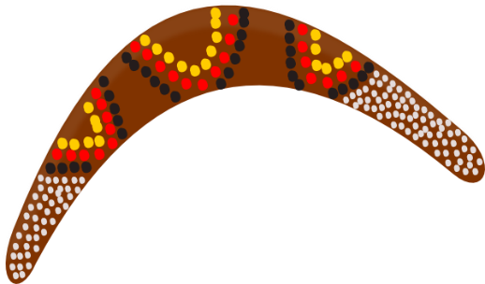
Year 2 Half Term Home learning
Life Down Under
Writing | Research |  | Creative
Plan an interview with somebody who lives in Australia. Think carefully about the questions you would ask them. | Research a state in Australia of your choice. Create a fact file about it. | Find Australia on a map. How far is it away from where you live? How could you travel there? How long might it take? | Draw and label a map of Australia.
Plan and make a tourist guide to Australia. Think about the places you could visit, how you would get there and the weather. | Find out how Australia is similar / different to where you live. | Research the Australian flag and draw a picture of it. | Design your very own boomerang.
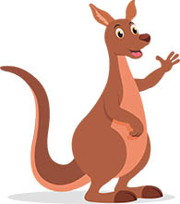  Write your very own song about Australia. | Research about some famous Australian dishes. Can you create one with your family. Remember to send in the pictures. | Research the different animals that live in Australia. Create a fact file about one of them. | 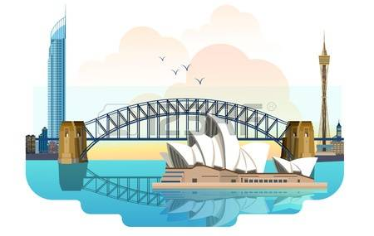  Research aboriginal dot art and create your very own picture.
The Home Learning is a choice menu and therefore there is not a specific task set each week, but instead all are laid out so you can choose when and which ones to complete throughout the term. We ask children to complete 1 topic-based task per week, thank you.

